PHASE 9: Reporting, Dashboards & Security Review – Documentation
- Custom Report Type
A custom report type was created for the Student object to enable reporting on custom student records.
Primary Object: Student__c
Category: Other Reports
Deployment Status: Deployed
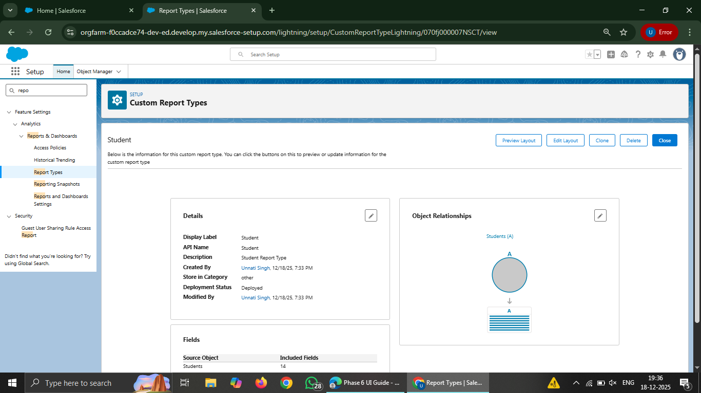

- Reports Creation
- 2.1 Tabular Report
A tabular report was created to display a simple list of students without any grouping.
Report Name: Student List Report
Fields Used: Student Name, Email, Phone
Purpose: To view all student records in a simple table format.
- 2.2Summary Report
A summary report was created by grouping student records based on fee status.
Report Name: Students by Fees Status
Grouping: Fees (Paid / Pending)
Purpose: To analyze students based on their fee payment status.
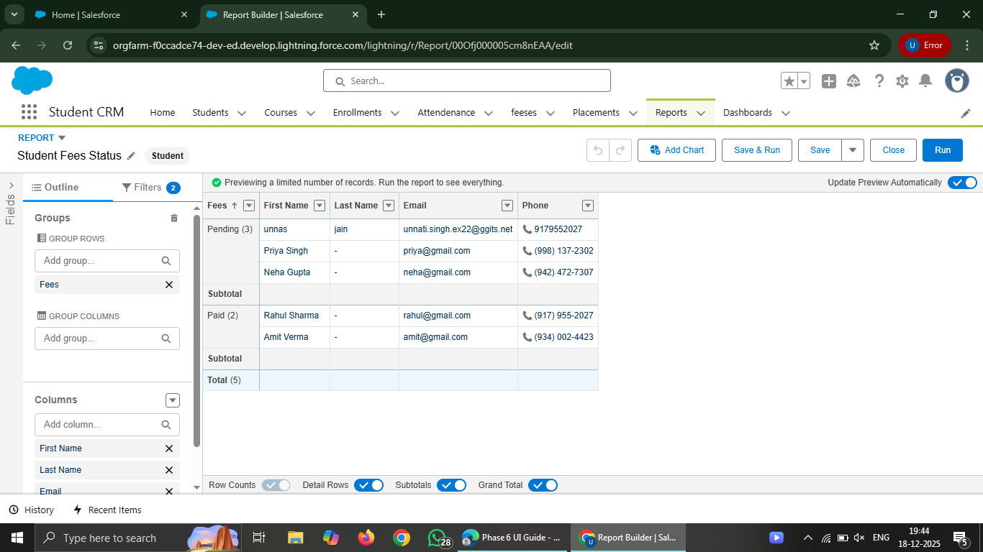
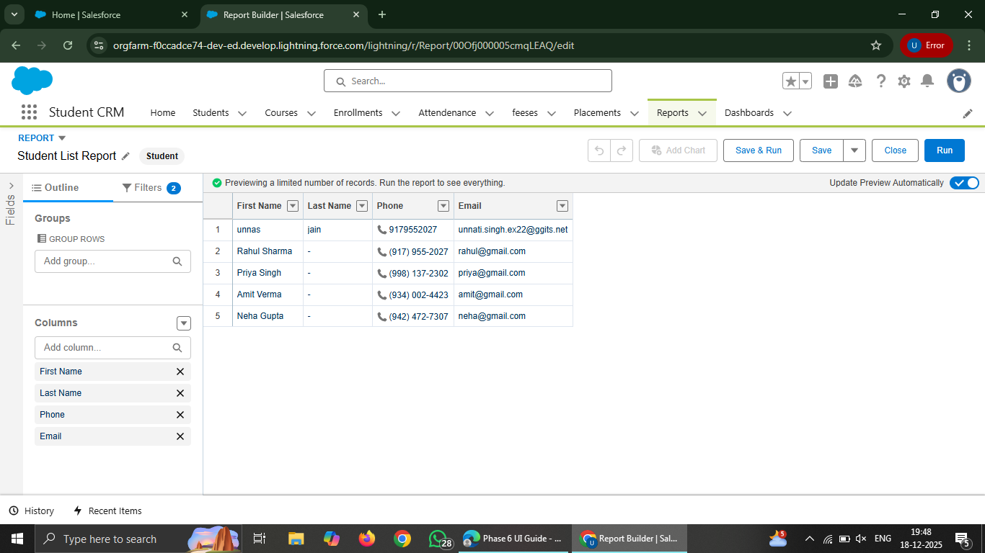
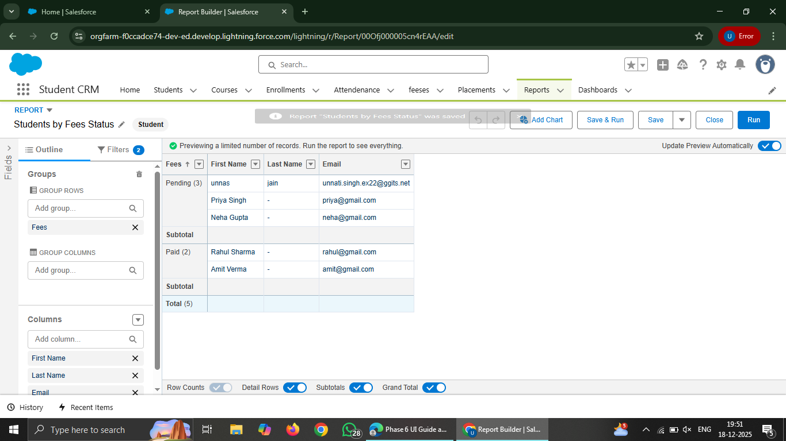
- 2.3Matrix Report
A matrix report was created to analyze student records using both row and column grouping.
Report Name: Student Fees Matrix Report
Row Group: Fees
Column Group: Created Date
Purpose: To analyze fee status across different time periods.
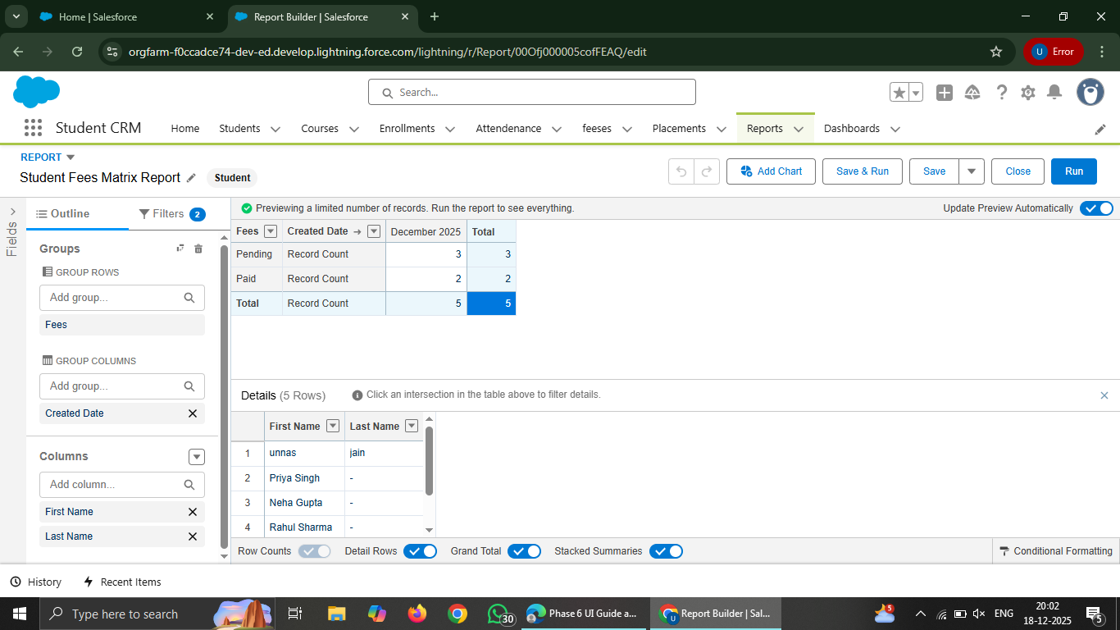

- Dashboard Creation
A dashboard was created to visually represent student data using the previously created reports.
Dashboard Name: Student CRM Dashboard
Folder: Private Dashboards
Dashboard Components
Total Students (Metric Component)
Source: Student List Report
Displays total number of students.
Students by Fees Status (Donut Chart)
Source: Students by Fees Status report
Shows Paid vs Pending students.
Fees Trend (Bar Chart)
Source: Student Fees Matrix Report
Shows fee trends over time.

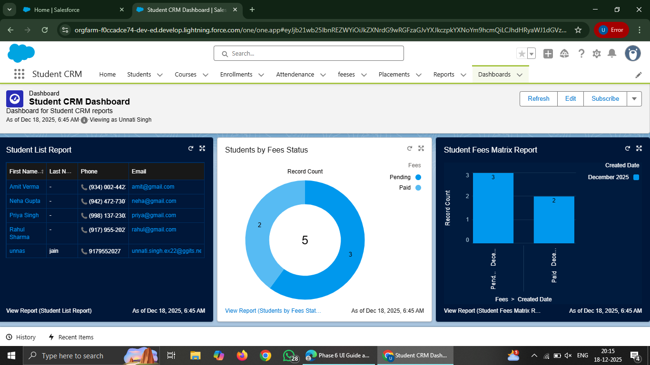

- Security Review

- 4.1 Sharing Settings
Organization-Wide Defaults were reviewed.
Student data access is restricted using private sharing settings.
- 4.2 Field Level Security
Field-level security was reviewed for sensitive fields such as Fees.
Field visibility is controlled based on user profiles.
- 4.3 Session Settings
Session settings were reviewed to ensure secure user sessions.
Session timeout and security controls were verified.
- 4.4 Login IP Ranges
Login IP ranges were reviewed.
No IP restrictions were enforced to allow flexible access.
- 4.5 Audit Trail
Setup Audit Trail was reviewed to track configuration changes and administrative actions.

